Architecture in general
Architecture – the process and the product of designing and constructing buildings.
Architecture can be variously defined (in conflicting ways) as:
- a general term to describe buildings and other physical structures – although not all buildings are generally considered to be architecture, and infrastructure (bridges, roads etc.) is civil engineering, not architecture.
-the art and science, or the action and process, of designing and constructing buildings.
- the design activity of the architect, the profession of designing buildings.
- a building designed by an architect, the end product of architectural design.
- a particular style or way of designing buildings.

Timeline of architecture (Some important architectural periods)
- Ancient Egyptian architecture –developed great architectural monuments along the Nile, among the largest and most famous of which are the Great Pyramid of Giza and the Great Sphinx of Giza.
- Maya and Inka architecture – the structures of the Maya and Inka civilization in the pre-Columbian period, known particularly for its exceptionally precise masonry. Some of its notable constructions include ceremonial platforms, palaces, pyramids, and temples....
- Sumerian architecture – the ancient architecture of the region of the Tigris–Euphrates river system (also known as Mesopotamia).
- Ancient Greek architecture –a precedent for the subsequent development of classical architecture.
- Ancient Roman architecture – adopted the principles of ancient Greek architecture and developed new decorative forms and much more complex building forms ( arches and vaults).
- Buddhist architecture – developed by the worshipers of Buddha in South Asia in the 3rd century BCE
- Byzantine architecture – the architecture of the Byzantine Empire.
- Islamic architecture – encompasses a wide range of both secular and religious styles from the foundation of Islam to the present day
- Medieval architecture – a term used to represent various forms of architecture common in Medieval Europe - Romanesque architecture and Gothic architecture
- Renaissance architecture – the architecture of the period between the early 15th and early 17th centuries in different regions of Europe, it revived certain elements of ancient Greek and Roman culture - Classical architecture and Baroque architecture
- Neoclassical architecture –began in the mid-18th century
- Victorian architecture –several architectural styles employed predominantly during the middle and late 19th century.
- Modern architecture – generally characterized by simplification of form and absence of ornament - Postmodern architecture and New Classical Architecture .

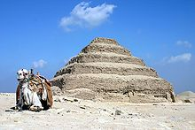
Pyramid of Djoser, a step pyramidbuilt during the 27th century BC.


The Parthenon in Athens is considered the pinnacle of ancient Greek architecture.
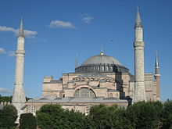
The Hagia Sophia, dating from 532AD, is one of the most famous examples of Byzantine architecture.

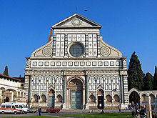
Renaissance façade of Santa Maria Novella in Florence.

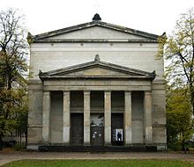
Restrained neoclassical style: the Elisabethkirche in Berlin.

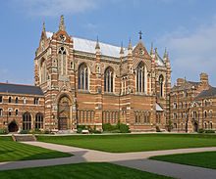
Keble College Chapel in Oxford, built in a gothic revival style.

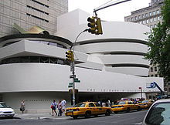
Solomon R. Guggenheim Museumin New York, by Frank Lloyd Wright.

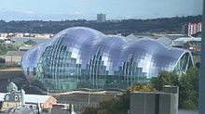
The Sage, Gateshead by Norman Foster: the trend towards organic shapes in contemporary architecture.

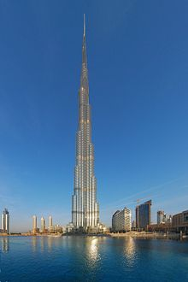
Burj Khalifa, Dubai: the tallestskyscraper in the world, completed in 2009.

Some basic tructural elements

- Arch – a curved structure, often made up of blocks or bricks, spanning across an opening and supporting the weight of structure above. Works by transferring vertical loads into compression forces. There are many arch shapes including semicircular, segmental, parabolic, pointed (gothic), and flat arches.
- Beam (structure) – a straight structural member, typically wood or steel, capable of spanning from one support to another and supporting the weight of structure above. Works by resisting bending forces.
- Buttress – a short section of masonry built at right angles to a wall, to resist lateral forces.
- Cantilever – a projecting structure without visible means of support at the projecting end.
- Column or pillar – a relatively slender structural element, typically circular, square or polygonal in plan, that bears the weight of the structure above.
- Dome – a roof structure, typically hemispherical, constructed in a similar way to an arch. The plan shape may be circular, elliptical or polygonal, and the cross section shape can vary in the same ways as an arch.
- Doorway – opening in a wall, typically rectangular, providing means of access, usually with a gate or door to provide security and weather protection.
- Facade – an exterior face of a building, especially the front.
- Foundation or footing – solid base usually below ground, upon which buildings and other structures are built. Works by spreading vertical loads over a sufficient area to ensure the structure will not subside.
- Lintel – a structural member spanning across the top of an opening. Unlike a beam, a lintel spans a relatively short distance which can be spanned by single block of stone of sufficient depth.
- Pier (architecture) – loadbearing structure similar to a column, but more massive.
- Truss – a structure spanning in the same way as a beam, but using materials more efficiently by using triangulation to create a rigid structure.
- Vault (architecture) – a curved masonry structure spanning in the same way as an arch, forming either a roof or support for a floor above.
- Wall – a linear structure enclosing the exterior of an area or building, or subdividing an internal space. A wall may be loadbearing or non-loadbearing.
- Window – an opening in a wall, typically rectangular, providing light and ventilation. Usually but not always glazed.

