SOME EXAMPLES OF FAMOUS ARCHITECTURE OF THE WORLD
Our list of 20 monuments of the world is assembled in the attempt to bring you closer the historical and the modern traits of what makes the famous architecture.
1. Eiffel Tower – Paris, France
Constructed in 1889, the Eiffel Tower is one of the most famous structures in the world. It’s named after the engineer Gustave Eiffel and it was build as the entrance arch for the World Expo of 1889. The tower is 324 meters high, approximately as an 81 storey building. Today, the tower attracts millions of visitors every year.
2. The Burj al Arab – Dubai
Built on an artificial island 280 meters away from the coast, the Burj al Arab in Dubai is one of the most luxurious and the fourth tallest hotel in the world. It’s 321 meters high and it represents one of the wonders of contemporary engineering. The building is designed by Tom Wright of WKK architects and its shape emulates shape of the sail of a ship.
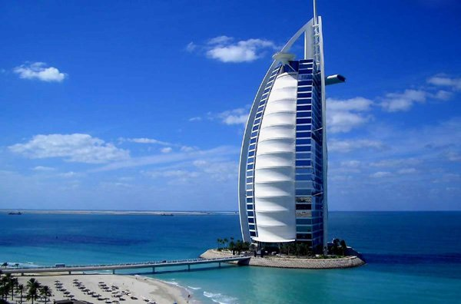
3. Parthenon – Athens, Greece
The most famous and the best preserved temple of ancient Greece had a lot of influence on the architecture, art and aesthetics of the western world. It was built in the 5th century BC, dedicated to the goddess Athena Parthenos, the patron of Athens. Its sculptures, ornaments and friezes are today considered the finest examples of Classical Greek art. Its supervising architect, Phidias is still known by name as one of the best sculptors and builders of the ancient times.
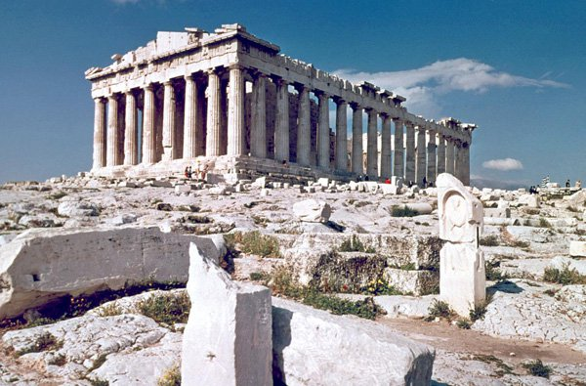
4. Sagrada Familia – Barcelona, Spain
One of the most elaborate churches in history, with a construction that has taken the most of the 20th century. Designed by one of the greatest minds of modern architecture, Antonio Gaudi, the cathedral represents the fantastic fusion of gothic influences and singular art nouveau ideas. It’s construction started in 1882, lasting through decades until the Spanish Civil War and the World War II, when it stopped. Resuming the building in the 1950s, the process is not over yet. Although the church has been consecrated in 2010, the final completion is planned for 2026, the year of 100 years anniversary of Gaudi’s death. Although unfinished, this building is huge and breathtaking with myriads of ornaments adorning its constructive elements, making it one of the most recognizable symbols of the city.
5. Angkor Wat – Cambodia
At first Hindu, then Buddhist, Angkor Wat was the most mysterious temple and the largest religious complex in the world. It was built in the 12th century by the Khmer King Suryavarman, intended to be the state temple and then his mausoleum. After Hinduist traditions were abandoned, Angkor Wat was dedicated to the Buddhist deity Vishnu. The complex is the symbol of Cambodia and it found its place on the Cambodian national flag. Vast and impressive, this brilliant example of Khmer architecture is captivating in its beauty and strong in its traditional structure.
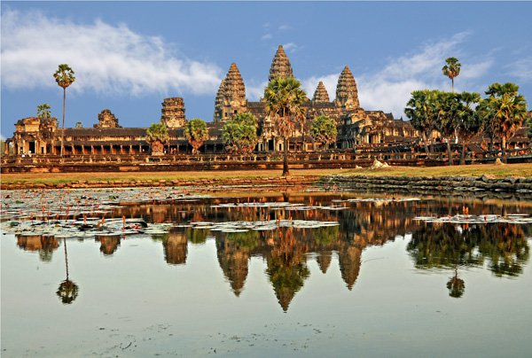

6. Saint Peter’s Basilica – Vatican, Rome, Italy
Probably the most famous Catholic church in the world, Saint Peter’s in Rome was designed by Donato Bramante, Michelangelo, Carlo Maderno and Gianlorenzo Bernini, respectively, with smaller additions by other prominent architects. It’s an elaborate basilica, and the most revered building of Renaissance architecture.
8. Colosseum
This ancient Roman amphitheatre is considered one of the greatest achievements of Roman architecture. It was constructed in 70-80 AD, and it’s one of the first buildings in history where concrete was used for construction.
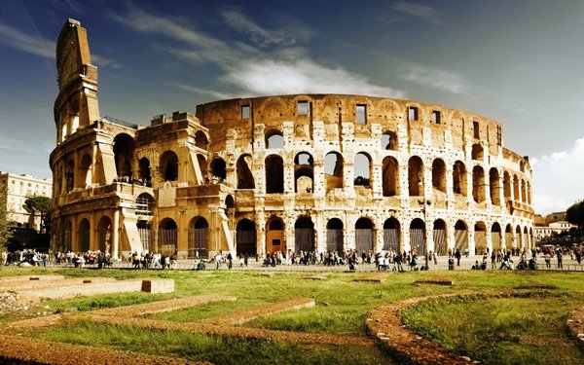
9. Tower Bridge London
The symbol of London and a pearl of the 19th century architecture, Tower Bridge was built as a combination of bascule bridge and suspension bridge in 1886 – 1894.
10. Hagia Sophia Istanbul
A monumental church, then mosque and today a museum. It’s a singular testimony to the grandeur and the genius of Byzantine architecture. It was built in 6th century AD, during the reign of Emperor Justinian.
11. Kremlin
Moscow Kremlin is a large fortified complex set in the bosom of Moscow. It was built in 15th century and the fortress spans over almost 28 hectares of land, with its impressive red walls, towers and buildings. It’s the seat of Russian government.

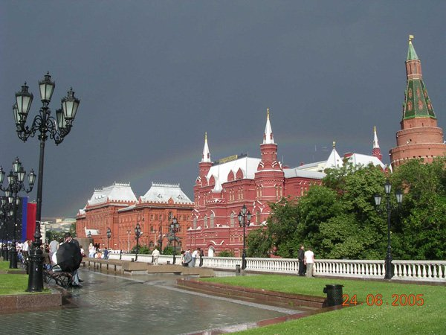

15. Leaning Tower Pisa
The campanile of the cathedral of Pisa, Tuscany is world famous for its leaning position. Started in the 12th, the tower was completed in the second half of the 14th century, and it is the iconic building of the late Italian Romanesque style.
16. Taj Mahal
Mughal emperor Shah Jahan built the most fantastic and the most beautiful monument to love, for his early deceased wife Mumtaz Mahal. The entire building is covered in white marble, depicting architecturally the ideal vision of heaven. Constructed in the 17th century, it is located in Agra, in the Indian region Uttar Pradesh.
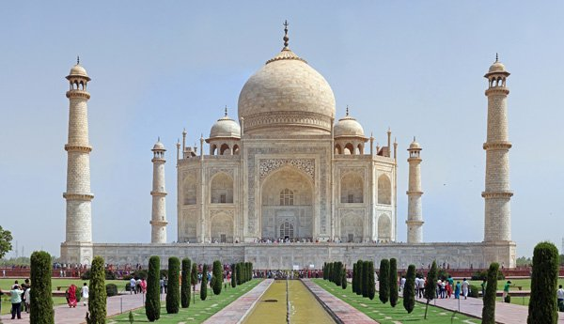
17. Sydney Opera House
One of the most famous opera houses in the world, because of its building. It was designed by Danish architect Jorn Utzon, who was celebrated for the groundbreaking modern design. Sydney Opera House was opened in 1973, staging large theatrical productions.
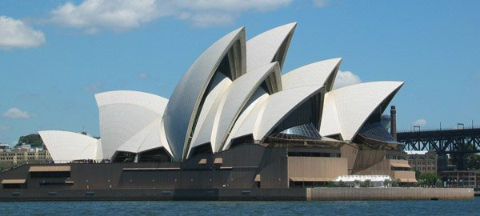

18. The Great Wall of is a series of fortifications of stone, brick, rammed earth, wood, and other materials, generally built along an east-to-west line across the historical northern borders of China to protect the Chinese empire against the raids and invasions of the various nomadic groups Several walls were being built as early as the 7th century BCE; these, later joined together and made bigger and stronger, are now collectively referred to as the Great Wall. Since then, the Great Wall has on and off been rebuilt, maintained, and enhanced; the majority of the existing wall is from the Ming Dynasty (1368–1644).

