The Pantheon

Built by Rome's Emperor Hadrian and completed in 125 AD, the Pantheon has the largest un-reinforced concrete dome ever built. The dome is 142 feet in diameter and has a 27-foot hole, called an oculus, at its peak, which is 142 feet above the floor. It was built in place, probably by starting above the outside walls and building up increasingly thin layers while working toward the center.
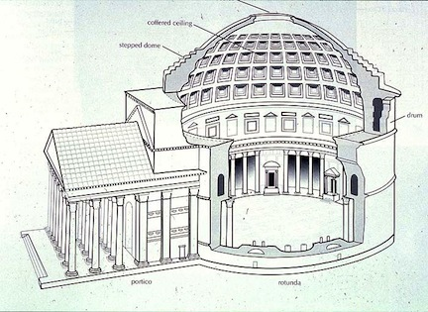
The Pantheon has exterior foundation walls that are 26 feet wide and 15 feet deep and made of pozzolana cement (lime, reactive volcanic sand and water) tamped down over a layer of dense stone aggregate. That the dome still exists is something of a fluke. Settling and movement over almost 2,000 years, along with occasional earthquakes, have created cracks that would normally have weakened the structure enough that, by now, it should have fallen. The exterior walls that support the dome contain seven evenly spaced niches with chambers between them that extend to the outside. These niches and chambers, originally designed only to minimize the weight of the structure, are thinner than the main portions of the walls and act as control joints that control crack locations. Stresses caused by movement are relieved by cracking in the niches and chambers. This means that the dome is essentially supported by 16 thick, structurally sound concrete pillars formed by the portions of the exterior walls between the niches and chambers. Another method to save weight was the use of very heavy aggregates low in the structure, and the use of lighter, less dense aggregates, such as pumice, high in the walls and in the dome. The walls also taper in thickness to reduce the weight higher up.

. Conclusion

Karta Bosanske ili Đakovačke i Srijemske biskupije iz 1826. godine vrijedan je povijesni dokument, koji obrađuje crkvene, svjetovne i prirodne sadržaje na obuhvaćenom području.

Sve prirodne ali i društvene znanosti vezane za prostor služe se kartama za stjecanje spoznaja o međuzavisnostima različitih prostornih objekata, za otkrivanje, istraživanje i lociranje daljih tematskih pojava i stanja te za prikaz određenih nakana.

Karta Bosanske ili Đakovačke i Srijemske biskupije iz 1826. godine je primjer karte koja može poslužiti za prostorne analize i istraživanja, provjere hipoteza i stjecanje novih spoznaja. Budući da su dani i prijevodi latinskih tekstova i statističkih podataka koji se nalaze na karti i uz kartu, otvaraju se mogućnosti za dalja istraživanja onodobnih pojava i stanja na obuhvaćenom području, povijesni pregled nastanka biskupije i dr.

Rad na svakoj karti, pa tako i na ovoj, odvijat će se sve dok god za njom postoji potreba i potražnja. Ako pogledamo unazad, možemo zaključiti o količini promjena koje su nastale u međuvremenu i kada je otprilike vrijeme za objavu nove verzije karte.

The Map of the Bosnia or Đakovo and Syrmia Diocese from 1826 is a valuable historical document which deals with ecclesiastical, secular and natural content of this area.
All natural and social sciences dealing with space use maps for acquiring knowledge of the interdependencies of various space objects, in order to detect, investigate and locate different thematic data, as well as to present specific intentions.

The Map of the Bosnia or Đakovo and Syrmia Diocese from 1826 is an example of the map that can be used for spatial analysis and researches, hypotheses proving and gaining new knowledge.

Since this paper involves translations of the Latin texts and statistical data presented inside and outside the map, it opens up new possibilities for further researches of past phenomena and conditions in the area, a historical overview of the diocese and similar.

Making of any map, and also of this one, will continue as long as the map is needed and useful. When looking into the past, we can draw conclusions about changes that happened in the meantime and when is the right time to make a new version of a map.

