SOME BASIC CIVIL ENGINEERING VOCABULARY AND TERMS FOR PART-TIME STUDY

civil engineering – građevinarstvo
civil engineer – inženjer građevinarstva
structural engineering – visokogradnja
transportation engineering – niskogradanja
hydraulic engineering – hidrotehnika
environmental engineering – inženjerstvo okoliša
construction industry – graditeljstvo
surveying - geodezija
(construction) site – gradilište
building site manager/ foreman – poslovođa
supervising engineer – nadzorni inženjer
construction/building material – građevni materijal
construction/building machine- građevinski stroj
(to sign a) contract – potpisati ugovor
to bid to a tender /competition - javiti se na tender/natječaj
to design (a road, dam, tunnel, building....) - projektirati ( cestu, branu, tunel, zgradu....)
design/ project - projekt
construction/building worker – građevinski radnik
construction/building work - građvinski posao (poslovi)
investor (building owner) – investitor, ulagač
contractor – ugovaratelj, izvođač

TRADITIONAL BUILDING MATERIALS, STRUCTURAL FORMS
post and lintel – stup i greda

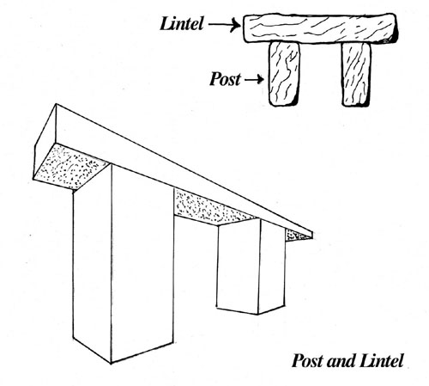

column=post= pier=pillar - stup
arch and vault – luk i svod
truss and cantilever – rešetka i konzola
limestone – vapnenac
sandstone - pješčenjak
mud - blato
baked/dried clay – pečena/sušena glina
pozzolana – pucolan
masonry brick – zidarska opeka
cast/wrought iron – lijevano/kovano željezo
volcanic ash – vulkanski pepeo
iron clamp - željezna spona, klema
bar/rod – šipka
to drill holes – izbušiti rupe
grains of sandstone pressed together – zbijena/stješnjena zrnca pješčenjaka
masonry – zidana konstrukcija
tile – keramička pločica, crijep
mortar – mort
binding material/agent – vezivni materijal

STEEL AND CONCRETE

alloy – legura
steel – čelik
carbon – ugljik
high quality iron ore – visokokvalitetna željezna ruda
corrosion resistance – otpornost na koroziju
hardness – tvrdoća
elasticity – elastičnost
ductility – rastezljivost (ductile copper - rastezljivi bakar)
malleability- kovnost, kovkost (malleable gold – kovno zlato)
toughness – žilavost (tough lead - žilavo olovo)
resistance to brittleness – otpornost na lomljenje
crushed rock – zdrobljeno kamenje
gravel – šljunak
reinforced/prestressed concrete – armirani/prednapeti beeton
compressive force – tlačna sila
tensile force – vlačna sila
versatility – svestranost (versatile concrete – svestrani beton)
to pour/spray concrete into different forms – lijevati /ubrizgavati beton u različite oplate
rate of expansion and contraction – stupanj širenja i skupljanja
to embed steel rods – ugraditi čelične šipke

CONCRETE, PROPERTIES OF MATERIALS

plain concrete – obični beton
versatile material (concrete) – svestrani materijal (beton)
exposed face – vidljiva strana
load bearing wall – nosivi zid
load bearing capacity/bearing load - nosivost
to exceed bearing capacity – premašiti nosivost
curtain wall – pregradni zid
strength to cost ratio – omjer snage i cijene
brittle – krhak, brittleness – krhkost
durable – trajan durability – trajnost
watertight – vodootporan watertightness – vodonepropustan
workable- obradiv workability – obradivost
buckling – izvijanje
( dry)shrinkage – (suho) skupljanje
loss in moisture – gubitak vlage
to cause cracking – uzrokovati pucanje
curing of concrete – zaštita betona

SOIL, BASIC GEOLOGIC TERMS

soil cpmposition – sastav tla
to obtain samples by boring soil – dobiti uzorke bušenjem tla
level of underground water/stream - razina podzemne vode
subsurface = underground
grain direction – smjer vlakana
composed of rock – sastavljen od stijenja (kamenja)
dense rock – gusto stijenje, kamenje
to exert strong pull – snažno privlačiti
settlement - slijeganje
compressible soil – stlačivo tlo
existence of faults – postojanje rasjeda
bearing pressure – nosivost
site investigation – pregled terena, (geotehničko) istraživanje lokacije
to dig a shallow pit – iskopati plitku građevinsku jamu
to transmit load to the ground – prijenos opterećanja na tlo
bearing layer – nosivi sloj
to cause man-made earthquake- prouzrokovati umjetni potres
water penetration - prodiranje vode
porous soil – šupljikavo tlo

SOME OTHER MECHANICAL PROPERTIES OF MATERIALS

ductility of copper – rastezljivost bakra
malleability – kovnost, kovkost
thermal conductance – toplinska vodljivost
conductivity – vodljivost
toughness - žilavost
to undergou serious damage- pretrpjeti ozbiljno oštećenje
to undergo plastic deformation – pretrpjeti plastičnu deformaciju
shock absorption – apsorpcija udara (amortizacija)
capable of absorbing strong shock – sposobna apsorbirati snažan udarac
to undergo dimensional changes – pretrpjeti dimenzionalne promjene
dry application – suha primjena
to resist deteriorating action – oduprijeti se propadanju
to differ in properties- razlikovati se po svojstvima
bent without breaking – savinut bez pucanja
subject to different forces – izložen/podvrgnut različitim silama
subject to shear – izložen/podvrgnut smiku/smicanju
water/earthquale/corrosion resistance – otpronost na vodu//potres//hrđanje

