***GEOMETRIJSKE KARAKTERISTIKE POPREČNIH PRESJEKA***

*Težište i statički moment površine*:

*Težište*:





*Statički moment površine*:



*Aksijalni (inercijalni) momenti tromosti*:



*Centrifugalni moment tromosti*:



*Polarni moment tromosti*:



1. Odredite geometrijske karakteristike poprečnog presjeka prikazanog slikom.

|  |  |
| --- | --- |
|  |  |

*Težište*:

|  |  |  |  |  |  |  |  |  |  |  |  |  |  |  |  |  |  |
| --- | --- | --- | --- | --- | --- | --- | --- | --- | --- | --- | --- | --- | --- | --- | --- | --- | --- |
|  | |  |  |  |  | | --- | --- | --- | --- | | *Površina* | *Ai*  [*mm2*] | *yTi*  [*mm*] | *zTi*  [*mm*] | | *A1* | **10000** | **100** | **25** | | *A2* | **20000** | **100** | **250** | | *A3* | **7500** | **100** | **475** | |





|  |  |
| --- | --- |
| *Koordinate težišta*:  *yT* = **100** *mm*  *zT* = **235** *mm* |  |

*Statički moment otpora:*

→ *maksimalni statički moment površine*:



|  |  |  |  |  |  |  |  |  |  |  |
| --- | --- | --- | --- | --- | --- | --- | --- | --- | --- | --- |
|  | |  |  |  | | --- | --- | --- | | *Površina* | *Ai*  [*mm2*] | *dTi*  [*mm*] | | *A1* | **10000** | **-210** | | *A2\** | **9250** | **-92.5** | |



*Inercijalni (aksijalni) momenti tromosti*:



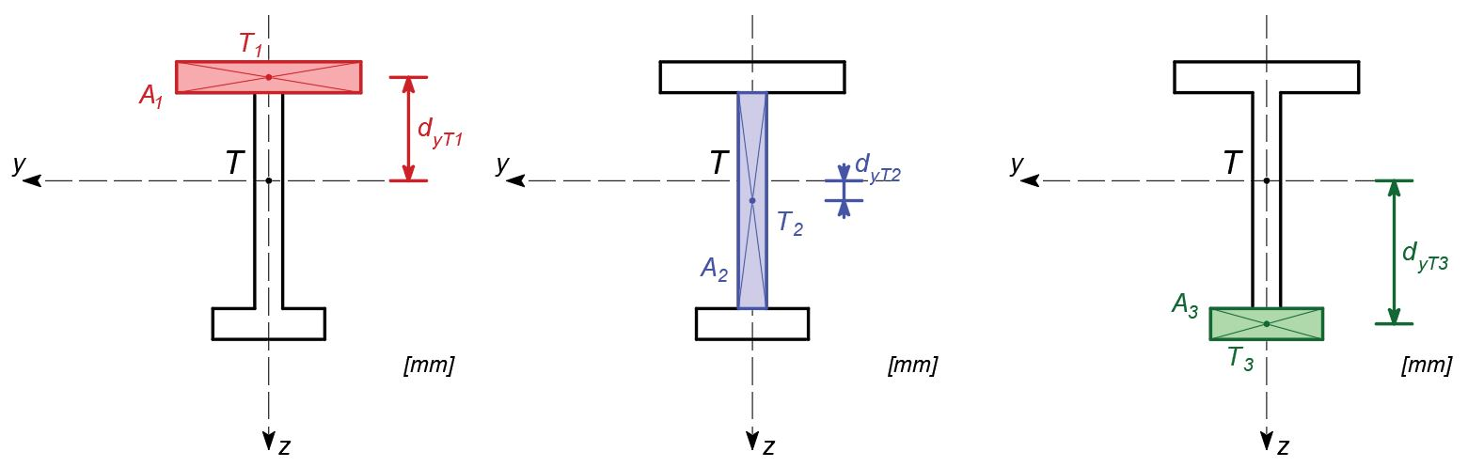

|  |  |  |  |  |  |
| --- | --- | --- | --- | --- | --- |
| *Površina* | *Ai*  [*mm2*] | *IyTi*  [*mm4*] | *IzTi*  [*mm4*] | *dyTi*  [*mm*] | *dzTi*  [*mm*] |
| *A1* | **10000** | **2083333.3** | **33333333.3** | **-210** | **0** |
| *A2* | **20000** | **266666666.7** | **4166666.7** | **15** | **0** |
| *A3* | **7500** | **1562500** | **14062500** | **250** | **0** |



*Polarni moment tromosti:*





2. Odredite geometrijske karakteristike poprečnog presjeka prikazanog slikom.

|  |  |
| --- | --- |
|  |  |

*Težište*:

|  |  |  |  |  |  |  |  |  |  |  |  |  |  |  |  |  |  |  |  |  |  |
| --- | --- | --- | --- | --- | --- | --- | --- | --- | --- | --- | --- | --- | --- | --- | --- | --- | --- | --- | --- | --- | --- |
|  | |  |  |  |  | | --- | --- | --- | --- | | *Površina* | *Ai*  [*mm2*] | *yTi*  [*mm*] | *zTi*  [*mm*] | | *A1* | **15000** | **150** | **25** | | *A2* | **17500** | **275** | **225** | | *A3* | **17500** | **25** | **225** | | *A4* | **30000** | **150** | **450** | |





|  |  |
| --- | --- |
| *Koordinate težišta*:  *yT* = **150** *mm*  *zT* = **271.9** *mm* |  |

*Statički moment otpora:*

→ *maksimalni statički moment površine*:



|  |  |  |  |  |  |  |  |  |  |  |  |  |  |
| --- | --- | --- | --- | --- | --- | --- | --- | --- | --- | --- | --- | --- | --- |
|  | |  |  |  | | --- | --- | --- | | *Površina* | *Ai*  [*mm2*] | *dTi*  [*mm*] | | *A1* | **15000** | **-246.9** | | *A2\** | **11095** | **-110.9** | | *A3\** | **11095** | **-110.9** | |



*Inercijalni (aksijalni) momenti tromosti*:



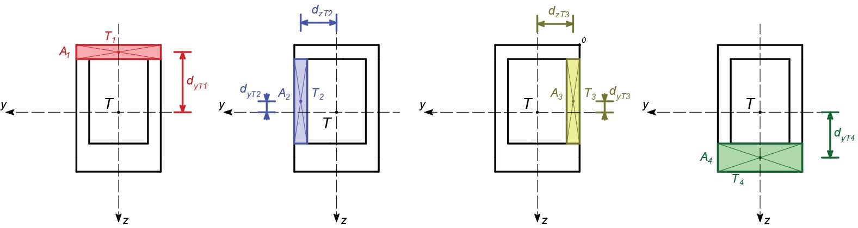

|  |  |  |  |  |  |
| --- | --- | --- | --- | --- | --- |
| *Površina* | *Ai*  [*mm2*] | *IyTi*  [*mm4*] | *IzTi*  [*mm4*] | *dyTi*  [*mm*] | *dzTi*  [*mm*] |
| *A1* | **15000** | **3125000** | **112500000** | **-246.9** | **0** |
| *A2* | **17500** | **178645833.3** | **3645833.3** | **-46.9** | **125** |
| *A3* | **17500** | **178645833.3** | **3645833.3** | **-46.9** | **-125** |
| *A4* | **30000** | **25000000** | **225000000** | **178.1** | **0** |



*Polarni moment tromosti:*



